# Business Requirements Document (BRD)

## 1. Problem Statement

The system currently calculates Ad Tech Fees at the vendor placement level and includes them in the client schedule without applying a markup. Unlike other charges, such as the management fee, which includes a markup to account for operational costs and client-specific adjustments, Ad Tech Fees are passed through without adjustment. This creates a disparity in how fees are calculated and represented to clients.  
  
To address this, a configurable markup mechanism for Ad Tech Fees must be introduced. This will ensure consistency, align with existing billing practices, and allow for flexible configuration at various levels to meet client-specific needs.

## 2. Current Process

Currently, Ad Tech Fees are calculated at the vendor placement level. These fees can either be percentage-based or fixed. Client schedules include summarized Ad Tech Fees from vendor placements, but no markup is applied. This results in inconsistencies in client-facing charges.

## 3. Proposed Solution

The system will introduce a configurable Ad Tech Markup mechanism to adjust Ad Tech Fees during client schedule generation. Markup percentages will be defined at the Media Placement Rate Type level and can be overridden at the Activity/Plan Level. The markup will be applied uniformly to summarized Ad Tech Fees during schedule generation.

## 4. Business Rules

### 4.1 Markup Definition

1. Media Placement Rate Type:  
 - Define the Ad Tech Markup (%) at this level to act as a default for any client using the rate card.  
2. Client Profile:  
 - Stamping the rate card propagates the default markup to new activities/plans only, without retroactively affecting existing ones.  
3. Activity/Plan Level:  
 - Users can override the default markup, with permissions controlling access (editable, read-only, or hidden).

### 4.2 Markup Application

1. Apply the configured markup to Ad Tech Fees calculated during client schedule generation.  
2. Summarized Fees:  
 - Markup applies to the summarized Ad Tech Fees for each client line.  
3. Manual Client Lines:  
 - Even for manually updated lines, the system will consistently apply the markup.

### 4.3 Manual Client Line Handling

1. No automatic markup for manual entries.  
2. Display system-recommended values based on the configured markup.

## 5. Impacted Areas

1. Buying (Insertion Orders):  
 - No changes to IO values. Markup remains client-facing only.  
2. Media Voucher UI:  
 - Continue displaying actual voucher amounts without markup.  
3. Post-Pay Billing:  
 - Display markup-adjusted guidance alongside actual IO amounts, retaining manual entry flexibility.  
4. Media Reconciliation:  
 - Apply markup during invoice generation, with clear UI indications for adjustments.  
5. Manual Client Lines:  
 - The system will apply the configured markup even if the client line is manually created or updated.

## 6. Non-Functional Requirements

1. Ensure efficient performance during client schedule generation.  
2. Validate Ad Tech Markup input values to accept only positive percentages.  
3. Maintain historical data integrity by ensuring no retroactive changes.

## 7. Out of Scope

1. Vendor-side changes are not included.  
2. No retroactive application of markup to historical data.  
3. Other fee types (e.g., management fees) remain unaffected.

## 8. Risks and Mitigation

1. Incorrect configuration may lead to billing discrepancies.  
 - Mitigation: Add validation and guided UI.  
2. Manual override errors could result in inconsistencies.  
 - Mitigation: Display system-recommended values and train users.  
3. Permissions mismanagement could allow unauthorized edits.  
 - Mitigation: Enforce role-based controls.

## 9. Assumptions

1. All clients using markup will have a stamped Media Placement Rate Type.  
2. Manual entries will still have system-applied markup during schedule generation.  
3. Permissions will be correctly configured to manage markup field visibility.

## 10. UI Changes

1. Media Placement Rate Type Screen:  
 - Add a new Ad Tech Markup (%) field in the header.  
 - Provide tooltips to describe the purpose of the field.  
 - Validate inputs to accept only positive percentages with up to two decimal places.  
2. Activity/Plan Screen:  
 - Add an Ad Tech Markup (%) field defaulting from the client profile.  
 - Apply rule-based permissions to make the field editable, read-only, or hidden.  
3. Post-Pay Billing Screen:  
 - Display the actual IO amount alongside the markup-adjusted amount.  
 - Provide tooltips explaining the adjustment.  
4. Media Reconciliation Screen:  
 - Show actual voucher and IO amounts in the selection grid.  
 - Include markup adjustments in the invoice preview with visual indicators.

## 11. UI Mockups

UI mockups include:  
1. Updated Media Placement Rate Type screen with the new Ad Tech Markup (%) field.  
  
  
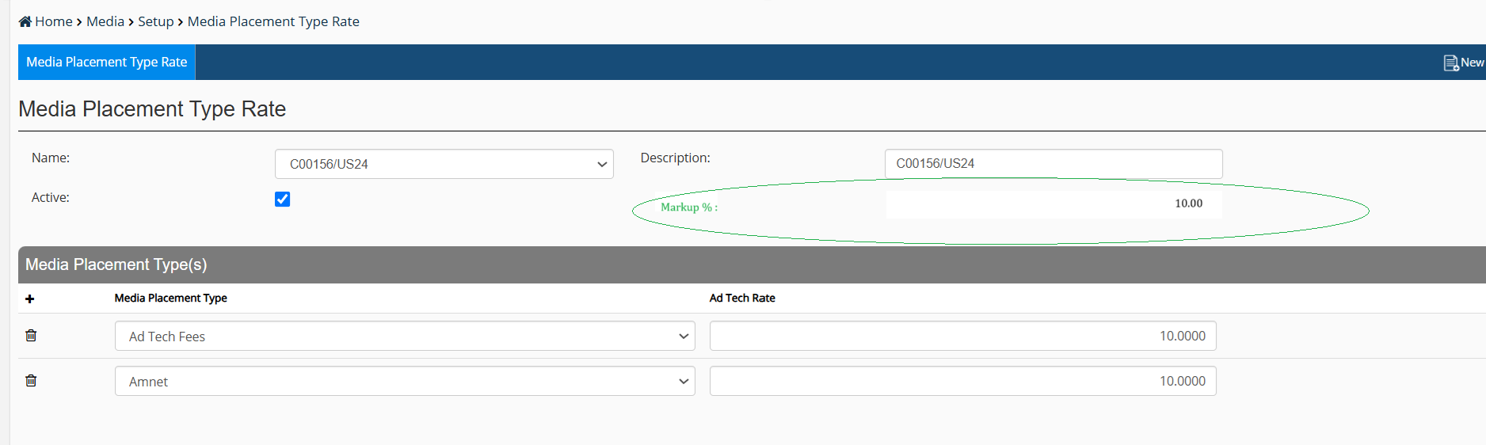  
  
  
2. Activity/Plan configuration screen showing default and override behavior.  
  
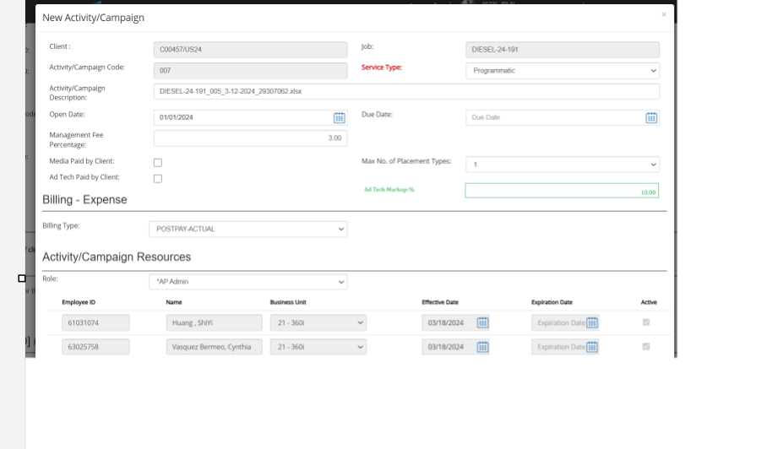

We will also have to add AdTech Markup field on regular level3 screen in media section.  
  
3. Post-Pay Billing screen highlighting markup-adjusted guidance.  
4. Media Reconciliation screen demonstrating visual cues for applied markup.

## 12. Next Steps

1. Review and finalize the BRD with all stakeholders.  
2. Develop mockups for all UI changes.  
3. Collaborate with the development team for effort estimation and technical design.  
4. Plan user training and documentation updates.